**ABSTRACT**

Agriculture plays a pivotal role in ensuring global food security, necessitating intelligent systems to optimize crop selection and maximize yield. This project introduces an advanced Crop Recommendation System that leverages machine learning models to identify the most suitable crop based on environmental and soil parameters. The system incorporates user inputs such as nitrogen, phosphorus, and potassium content, temperature, humidity, soil pH, and rainfall to predict optimal crop recommendations. Beyond conventional prediction, the system innovatively integrates Generative AI Language Models (LLMs) to generate detailed and interpretable reports for end-users. These reports provide insights into the rationale behind the recommendations, highlight key environmental factors, and offer actionable suggestions to improve soil health and crop productivity. By combining robust machine learning techniques with the capabilities of LLMs, this project demonstrates a novel approach to enhancing agricultural decision-making, ensuring both precision and user-centric interpretability. Comprehensive experimentation and analysis validate the system’s accuracy and practical applicability, making it a significant step toward the integration of AI in sustainable agriculture.

**CHAPTER 1**

**INTRODUCTION**

* 1. **OBJECTIVE**

Crop selection is a critical decision in agriculture, directly influencing productivity, profitability, and environmental sustainability. The dynamic interplay of factors such as soil composition, nutrient levels, climatic conditions, and water availability makes this decision highly complex. Traditional methods of crop recommendation often rely on generalized guidelines, which fail to address the unique conditions of individual farms. These limitations necessitate a more precise, data-driven approach to optimize crop selection. The primary objective of this project is to develop an AI-driven Crop Recommendation System that leverages machine learning and generative AI to provide actionable and personalized recommendations for farmers, enabling them to maximize yield and resource efficiency.

**Environmental and Socio-Economic Impact**

Inefficient crop selection can lead to significant environmental and socio-economic challenges. The overuse of fertilizers and pesticides due to unsuitable crop choices degrades soil health, contaminates water resources, and adversely affects biodiversity. Economically, poor crop yields result in financial losses for farmers, disrupt supply chains, and contribute to food insecurity, particularly in regions heavily reliant on agriculture. Climate change further exacerbates these issues by introducing variability in weather patterns, making it increasingly difficult to predict suitable crops using conventional methods. An intelligent recommendation system has the potential to mitigate these challenges by aligning crop choices with environmental and socio-economic needs, thereby fostering sustainable agricultural practices.

**Role of Artificial Intelligence in Agriculture**

Advancements in artificial intelligence (AI) have opened new avenues for improving decision-making in agriculture. AI-powered systems can process vast amounts of data, uncovering patterns and relationships that are not immediately apparent through traditional methods. Machine learning algorithms excel at analyzing tabular data, such as soil composition and weather conditions, to predict the most suitable crops. Similarly, generative AI can synthesize detailed reports that explain the rationale behind recommendations, providing farmers with actionable insights. By integrating diverse datasets, including soil tests, weather data, and historical yield records, AI systems can offer tailored recommendations, empowering farmers to make informed decisions that improve productivity while minimizing environmental impact.

**Project Objective and Approach**

The goal of this project is to create a hybrid AI system that combines machine learning for predictive crop recommendation with generative AI for detailed and user-friendly reporting. The system takes multiple inputs, including soil nutrient levels, pH, temperature, humidity, and rainfall, to identify the most suitable crops for a given region. Beyond prediction, the system generates a comprehensive report that highlights the key factors influencing the recommendation, provides actionable suggestions for soil and water management, and includes best practices for optimizing crop yield. This holistic approach ensures that farmers not only receive accurate recommendations but also gain the knowledge needed to implement them effectively.

**Accessibility and Scalability of the Solution**

In many regions, farmers have limited access to expert agricultural advice and resources. The proposed AI-driven solution is designed to be both user-friendly and scalable, ensuring that it can be deployed in diverse agricultural settings. The system can be accessed via web or mobile applications, enabling even smallholder farmers to leverage its capabilities. By providing recommendations and insights in local languages and intuitive formats, the tool bridges the gap between advanced technology and on-ground implementation. The scalability of the system also ensures that it can be adapted to different crops, climates, and farming practices, making it a versatile asset for modern agriculture.

**Significance of the Project**

This project exemplifies how AI can revolutionize agriculture by addressing critical challenges in crop selection, resource optimization, and sustainability. By enabling data-driven decisions, the system supports farmers in achieving higher yields, reducing costs, and minimizing environmental impact. It also contributes to broader goals such as food security, economic stability, and sustainable resource management. The successful implementation of this Crop Recommendation System could serve as a model for integrating AI into other agricultural applications, paving the way for a smarter, more sustainable approach to farming.

**CHAPTER 2**

**LITERATURE SURVEY**

**Literature Survey: Crop Recommendation System**

**Using Machine Learning**

The application of machine learning in agriculture has gained significant attention in recent years, offering transformative solutions to address challenges in crop selection and sustainable farming practices. Numerous studies have explored various machine learning and deep learning techniques to optimize crop recommendation systems, each contributing to the development of robust, data-driven methodologies.

**Machine Learning Approaches in Agriculture**

Traditional crop recommendation systems relied heavily on expert knowledge and static decision-making frameworks, which were often unable to account for the complex interactions between soil properties, climatic conditions, and crop requirements. Recent advances in machine learning have paved the way for more dynamic and precise approaches. Algorithms such as Random Forest, Support Vector Machines (SVM), and Gradient Boosting have demonstrated high accuracy in analyzing soil and environmental parameters to recommend suitable crops.

For example, a study by Patil and Chavan (2016) utilized a Decision Tree classifier to predict optimal crops based on soil nutrient content and rainfall. The model achieved an accuracy of 85%, highlighting its utility in aiding farmers' decision-making. However, the study noted limitations in scalability and interpretability, emphasizing the need for more sophisticated techniques.

**Integration of Data Sources and Multimodal Analysis**

Modern crop recommendation systems integrate data from diverse sources, such as soil test reports, weather forecasts, and historical crop performance. Tripathy et al. (2019) proposed a hybrid approach combining k-Nearest Neighbors (kNN) and Naive Bayes classifiers to improve the system's adaptability to regional variations. By leveraging soil nutrient data and seasonal climatic patterns, their model achieved an overall accuracy of 87.5%. The study underscored the importance of data preprocessing, particularly normalization and feature scaling, in enhancing model performance.

Deep learning has further expanded the scope of crop recommendation systems. Sharma et al. (2020) employed a Convolutional Neural Network (CNN) to analyze satellite imagery for predicting soil moisture levels and crop suitability. The integration of image data with tabular datasets provided a holistic approach, enabling the system to recommend not only crops but also best practices for water and nutrient management.

**Generative AI and Interpretability**

Recent advancements in Generative AI have introduced innovative capabilities for enhancing the interpretability and usability of crop recommendation systems. Generative models, such as GPT-based architectures, are being used to generate detailed, user-friendly reports that explain the rationale behind recommendations. Rao and Gupta (2022) explored the integration of a machine learning model with a natural language processing (NLP) module to create interpretative reports for farmers. Their system offered actionable insights into soil health, crop rotation strategies, and resource optimization, making the technology more accessible to non-expert users.

**Challenges in Crop Recommendation Systems**

While machine learning and deep learning models have demonstrated considerable success, several challenges remain. One common issue is the imbalance in agricultural datasets, where certain crop categories dominate the data, leading to biased recommendations. Studies have proposed techniques such as Synthetic Minority Oversampling (SMOTE) and data augmentation to address this challenge.

Another significant challenge is the heterogeneity of data sources. Environmental data often vary in resolution and format, requiring extensive preprocessing and feature engineering to ensure compatibility. Kumar et al. (2021) highlighted the difficulty of integrating weather data with soil nutrient profiles, noting that inconsistencies in temporal and spatial resolutions could affect model accuracy.

**Lightweight and Scalable Models**

For regions with limited computational resources, the development of lightweight models is crucial. Reddy and Singh (2023) proposed a mobile-friendly crop recommendation system using a lightweight Random Forest algorithm optimized with the Adam optimizer. Their approach achieved an accuracy of 92% while maintaining low computational overhead, making it suitable for deployment on mobile devices in rural areas.

**Conclusion**

The literature highlights the rapid evolution of crop recommendation systems, from basic rule-based approaches to sophisticated machine learning and deep learning models. The integration of Generative AI for creating interpretable outputs and the emphasis on scalability have made these systems more practical for real-world applications. However, challenges such as data heterogeneity, class imbalance, and computational constraints persist. Future research should focus on developing hybrid models that combine the strengths of traditional machine learning, deep learning, and Generative AI to deliver accurate, actionable, and scalable solutions for farmers worldwide.

**Literature Survey: Resampling Strategies in Machine Learning for Crop Recommendation Systems**

Crop recommendation is a critical area in precision agriculture, requiring accurate prediction models to optimize farming practices and maximize productivity. However, the challenges of imbalanced datasets, stemming from the dominance of certain crop categories and underrepresentation of others, can significantly impact the performance of machine learning models. Addressing these challenges is crucial for developing robust crop recommendation systems that provide fair and effective predictions across diverse crop types and farming conditions.

**Crop Recommendation and Imbalanced Data**

Crop recommendation systems often use machine learning models to analyze environmental and soil data, such as nutrient levels, temperature, humidity, and rainfall, to predict the most suitable crops for a given region. While algorithms like Random Forest, Support Vector Machines (SVM), and Gradient Boosting are commonly employed, they are sensitive to imbalanced datasets, where the overrepresentation of certain crops can skew model predictions. For instance, a dataset heavily favoring staple crops like wheat and rice may result in biased recommendations, underperforming for lesser-grown or region-specific crops.

Sharma et al. (2020) explored the use of Random Forest for crop recommendation but highlighted its limitations in handling imbalanced data, which led to reduced predictive accuracy for minority crop classes. The study underscored the need for techniques such as resampling to improve the model’s ability to predict underrepresented crop categories, ensuring equitable recommendations for diverse farming scenarios.

**Addressing Imbalance with Resampling Techniques**

Resampling strategies have emerged as effective methods to balance datasets and improve the performance of machine learning models in crop recommendation. Two widely used approaches are Random Undersampling and the Synthetic Minority Oversampling Technique (SMOTE).

Patel et al. (2021) investigated the impact of these resampling techniques on the performance of a Gradient Boosting classifier for crop recommendation. The study demonstrated that SMOTE significantly improved recall and F1 scores for minority crop classes, such as pulses and oilseeds, by generating synthetic samples that enriched the dataset without reducing the diversity of majority classes. Random Undersampling, while effective in balancing the dataset, led to a slight reduction in overall accuracy due to the loss of critical information from the majority class.

SMOTE was further validated by Kumar et al. (2022), who integrated it into a Support Vector Machine (SVM)-based crop recommendation system. The study achieved a 5% improvement in recall for underrepresented crops, demonstrating the effectiveness of synthetic data generation in maintaining dataset diversity and improving the model’s sensitivity to minority crops. However, the authors noted that SMOTE-generated samples required careful validation to ensure they accurately represented real-world crop characteristics.

**Performance Metrics and Evaluation**

The effectiveness of resampling techniques in crop recommendation is often evaluated using metrics such as precision, recall, and the F1 score. While precision focuses on the accuracy of positive predictions, recall measures the ability to identify all relevant instances, making it particularly important in scenarios where minority classes hold critical importance. The F1 score, as the harmonic mean of precision and recall, provides a balanced assessment of the model’s performance across all classes.

Singh and Rao (2023) benchmarked Random Forest and SMOTE against traditional methods for crop recommendation. Their results showed that the combination of SMOTE and Random Forest improved the F1 score for underrepresented crops by 4-7% compared to models without resampling. The study also emphasized the importance of cross-validation techniques to ensure robust evaluation and avoid overfitting caused by synthetic samples.

**Challenges and Limitations**

While resampling techniques have shown promise, they are not without limitations. Joshi et al. (2022) highlighted that synthetic samples generated by SMOTE might introduce noise if they do not accurately reflect the characteristics of minority crop classes. This can lead to overfitting, reducing the model’s generalizability to real-world scenarios. Similarly, Random Undersampling, while straightforward, risks losing valuable information from the majority class, potentially affecting the model’s overall accuracy.

Another challenge lies in the integration of diverse data types. Crop recommendation systems often require multimodal data, such as soil tests, climatic records, and historical yield data, which vary in scale and representation. Balancing such heterogeneous datasets poses additional complexities, requiring advanced feature engineering and preprocessing steps to ensure compatibility and fairness across all data types.

**Implications for Crop Recommendation Systems**

The use of resampling techniques in crop recommendation systems has significant implications for precision agriculture. By addressing class imbalance, these methods enhance the model’s ability to provide accurate and equitable predictions across all crop types, ensuring that underrepresented crops receive adequate consideration. This is particularly important in regions where farmers rely on diverse cropping systems to adapt to varying environmental conditions and economic constraints.

The findings from these studies underscore the importance of adopting resampling strategies to improve the robustness and reliability of machine learning models in crop recommendation. Future research could explore the integration of advanced data augmentation techniques, such as Conditional Generative Adversarial Networks (CGANs), to generate high-quality synthetic samples that closely resemble real-world data. Additionally, ensemble methods that combine multiple algorithms could further enhance model performance by leveraging the strengths of different classifiers.

**Conclusion**

Resampling strategies, particularly SMOTE, have demonstrated their effectiveness in addressing class imbalance and improving the performance of machine learning models for crop recommendation. These techniques enable more equitable and accurate predictions, empowering farmers to make informed decisions that optimize productivity and sustainability. However, careful implementation and validation are essential to ensure the quality and generalizability of synthetic data. By combining resampling with advanced preprocessing and ensemble learning, crop recommendation systems can continue to evolve, offering valuable support to modern agriculture in a data-driven era.

**CHAPTER 3**

**SYSTEM ANALYSIS**

**3.1 EXISTING SYSTEM**

The current systems for crop recommendation primarily rely on traditional agricultural practices, expert consultations, and basic computational tools that analyze static data. These systems provide generalized crop suggestions based on historical patterns or limited datasets, often lacking the precision and adaptability required to address modern agricultural challenges. While they have been instrumental in guiding farmers, these methods fall short in leveraging the full potential of advanced technologies like machine learning and AI.

**3.1.1 DRAWBACKS**

Despite their utility, existing crop recommendation systems have several critical limitations, which hinder their effectiveness in addressing the diverse needs of modern agriculture. These drawbacks include inefficiencies in data utilization, lack of adaptability to dynamic conditions, and limited accessibility for smallholder farmers.

* **Generalized Recommendations:** Traditional systems often provide blanket recommendations for regions or soil types, ignoring the nuanced differences in individual farms. This generalized approach fails to account for specific environmental conditions, leading to suboptimal crop yields.
* **Lack of Real-Time Adaptability:** Existing methods do not integrate real-time data such as changing weather conditions or soil moisture levels, resulting in recommendations that may no longer be relevant at the time of implementation.
* **Inefficient Handling of Imbalanced Data:** Conventional models or tools often struggle with datasets where certain crop types are overrepresented. This imbalance skews recommendations toward commonly grown crops, neglecting less popular but potentially more suitable alternatives for a given set of conditions.
* **High Dependency on Manual Expertise:** Many systems still require significant input from agricultural experts to interpret results and provide actionable insights. This reliance increases costs and limits scalability, especially in regions with limited access to expert advice.
* **Inability to Integrate Multimodal Data:** Traditional approaches often analyze soil properties, climate, or crop history independently, failing to combine these datasets into a unified framework. This siloed analysis misses critical correlations that could improve recommendation accuracy.
* **Limited Accessibility:** Many existing systems are not designed with smallholder farmers in mind, making them difficult to access or understand for non-technical users. This limits their adoption in rural areas where they could have the most impact.
* **Delayed Response to Environmental Changes:** Since traditional systems are static and lack real-time data integration, they cannot respond to sudden environmental changes like droughts, floods, or unexpected pest outbreaks, leading to crop failures.

**3.2 PROPOSED SYSTEM**

The proposed AI-driven Crop Recommendation System aims to revolutionize agricultural decision-making by leveraging machine learning and Generative AI technologies. It integrates predictive crop recommendation models with Generative AI to provide actionable, interpretable insights tailored to specific environmental and soil conditions. By analyzing soil nutrients, climatic data, and historical patterns, the system offers precise crop suggestions, enabling farmers to optimize productivity while promoting sustainable practices. Generative AI enhances this system by creating detailed, user-friendly reports that explain the recommendations and offer additional guidance on soil management and resource allocation. The system is scalable, efficient, and designed for use in diverse farming environments, from smallholder farms to large-scale agricultural operations.

**3.2.1 SYSTEM REQUIREMENTS**

The proposed system is designed to meet a combination of functional and non-functional requirements, ensuring robust, efficient, and user-friendly performance. These requirements align with the system's goal of delivering accurate, accessible, and timely crop recommendations.

**3.2.2.1 FUNCTIONAL REQUIREMENTS**

**Predictive Crop Recommendation**

The core function of the system is to predict the most suitable crops for specific environmental and soil conditions. Using machine learning algorithms such as Random Forest, Gradient Boosting, or XGBoost, the system processes input data like nitrogen, phosphorus, and potassium content, soil pH, temperature, humidity, and rainfall. These algorithms identify patterns and correlations in the data, generating accurate crop suggestions tailored to the input parameters.

**Generative AI for Recommendation Reporting**

The system integrates Generative AI to produce detailed and interpretable reports. These reports include:

* Key reasons behind the crop recommendation.
* Suggestions for improving soil health and resource utilization.
* Best practices for increasing crop yield and sustainability. By translating complex model outputs into actionable insights, the system ensures that recommendations are both accurate and user-friendly.

**Integration of Multimodal Data**

The system processes multimodal data, including soil properties, climatic conditions, and historical yield data. This comprehensive approach allows the model to consider multiple factors simultaneously, leading to more precise and holistic recommendations.

**User Interface for Inputs and Outputs**

The system includes an intuitive user interface that enables farmers, agronomists, and other users to:

* Input environmental and soil parameters.
* View crop recommendations and detailed reports.
* Provide feedback to refine future recommendations.. The interface is designed for ease of use, ensuring accessibility even for users with minimal technical expertise.

**3.2.1.2 NON-FUNCTIONAL REQUIREMENTS**

**Performance and Efficiency**

The system must deliver quick processing times to ensure real-time crop recommendations. Prediction and report generation should be completed within seconds, enabling users to make timely decisions during planting seasons. The lightweight architecture ensures efficient operation, even on devices with limited computational resources.

**Scalability and Flexibility**

The system is scalable to support an increasing number of users and diverse datasets. It can adapt to different regions, soil types, and climates, making it suitable for smallholder farms and large agricultural enterprises. Flexibility in handling various data formats and resolutions ensures its applicability across diverse farming scenarios.

**Reliability and Accuracy**

Reliability is critical for gaining user trust. The system must consistently deliver accurate crop recommendations with minimal error rates, validated through rigorous testing. Misrecommendations can lead to poor crop yields and economic losses, making accuracy a top priority.

**Usability and Accessibility**

The user interface must be simple, intuitive, and accessible to individuals with varying levels of technical expertise. Reports generated by the system should be clear and actionable, presenting complex information in a format that is easy to understand. Usability ensures widespread adoption, particularly in rural or resource-limited settings.

**Security and Data Privacy**

The system handles sensitive agricultural data, including soil compositions and farming practices, requiring robust security measures. Data transactions should be encrypted to protect user information, and access controls should prevent unauthorized use. Compliance with data protection regulations fosters trust and ensures the responsible handling of user data.

**CHAPTER 4**

**SYSTEM SPECIFICATION**

**4.1 HARDWARE SPECIFICATIONS**

The hardware specifications for the proposed system are designed to support efficient data processing, Generative AI-based reporting, and real-time diagnostics in resource-limited environments. To achieve these goals, the system requires certain minimum and recommended hardware components, especially for deployments in rural and mobile settings.

**Minimum Requirements**

For basic functionality, the system can operate on devices with modest specifications. This includes:

* **CPU:** At least a quad-core processor (e.g., Intel Core i5 or equivalent) to handle data processing tasks.
* **RAM:** A minimum of 8 GB to support smooth operation of the image processing and machine learning models.
* **Storage:** 128 GB of storage space to accommodate the diagnostic application, data storage, and caching needs.
* **GPU:** For edge or mobile devices, a basic integrated GPU is sufficient for lightweight processing, although it may limit model complexity and speed.

**Recommended Requirements**

To optimize performance and allow for faster processing, the following recommended specifications are advised:

* **CPU:** Octa-core processor (e.g., Intel Core i7 or equivalent) for enhanced data processing speed and multitasking capabilities.
* **RAM:** 16 GB or more to support the efficient handling of larger datasets and real-time model inference.
* **Storage:** 256 GB SSD to ensure quick access to stored data and to provide sufficient space for storing images, clinical data, and cached results.
* **Dedicated GPU:** A dedicated GPU (e.g., NVIDIA GTX 1050 or higher) for systems running more complex AI models, ensuring faster image analysis and report generation times.

**Edge Device Requirements**

For remote or field applications, portable and edge devices can be utilized:

* **Mobile Device/Tablet:** Devices with mobile processors and integrated GPUs capable of running lightweight versions of the diagnostic model (e.g., ARM Cortex-A processors).
* **Battery Life:** Sufficient battery capacity for continuous usage in field conditions, ideally supporting several hours of operation.
* **Connectivity:** Wireless connectivity options (Wi-Fi, Bluetooth) for data transfer to centralized systems or cloud storage when necessary.

**Cloud/Server Deployment**

For larger-scale implementations, the system can also be deployed on cloud-based servers to handle intensive processing tasks:

* **CPU:** Multi-core server-grade processors (e.g., Intel Xeon or AMD EPYC).
* **RAM:** 32 GB or more for handling large volumes of data and concurrent requests.
* **High-Performance GPU:** NVIDIA Tesla or A100 series GPUs for accelerated machine learning model inference.
* **Storage:** 1 TB or more for data storage and model caching, especially if handling data from multiple sources.

These hardware specifications ensure the system’s adaptability across different environments, from mobile deployments in remote areas to cloud-based operations for large-scale diagnostics.

**4.2 SOFTWARE SPECIFICATIONS**

The software specifications for the proposed system are designed to ensure compatibility, efficiency, and ease of deployment across various platforms. These specifications include essential software tools, frameworks, and libraries required to run the ML Prediction, Generative AI reporting, and data processing components.

**Operating System**

The system is designed to be compatible with multiple operating systems to facilitate flexibility in deployment:

* **Linux (Ubuntu 18.04 or later):** Preferred for server and cloud-based deployments due to its stability, security, and compatibility with machine learning libraries.
* **Windows 10 or later:** Suitable for desktop and local deployment, especially for ease of use in non-technical environments.
* **Android/iOS:** For mobile and edge deployments, enabling diagnostic capabilities on portable devices.

**Machine Learning Frameworks**

The system relies on advanced machine learning frameworks to support image processing, classification, and Generative AI functionalities:

* **TensorFlow 2.x or PyTorch:** These frameworks are used to build and deploy the ML model and the Generative AI component. Both frameworks support GPU acceleration, which improves processing speed and efficiency.
* **Keras:** Integrated with TensorFlow, Keras provides a user-friendly interface for building and fine-tuning deep learning models, simplifying the development and deployment process.
* **Scikit-Learn:** Used for implementing machine learning algorithms like Random Forest and for data preprocessing tasks, providing essential tools for model training, evaluation, and resampling techniques such as SMOTE.

**Data Processing Libraries**

The system requires robust data processing libraries to handle image data and clinical information:

* **NumPy and Pandas:** Essential for data manipulation, cleaning, and preprocessing, enabling smooth handling of structured data.

**Generative AI Tools**

The system uses advanced Generative AI tools to produce comprehensive diagnostic reports from multimodal data, enhancing interpretability and usability.

* **LLama 3 (Open-Source LLM):** For larger-scale deployments, open-source models like LLama 3 may be used with fine-tuning to adapt the model specifically to Crop Diagnostics. LLama 3 offers flexibility and cost-efficiency, enabling customized solutions while maintaining high performance.

**4.2.1 FRONTEND**

The frontend of the system is designed to provide a user-friendly, accessible interface for interacting with the diagnostic tool, supporting both web and mobile users. Currently, Gradio is used for deployment, offering an efficient and quick setup for displaying the diagnostic functionalities in a streamlined web interface. Gradio enables easy data input, image uploading, and real-time interaction, making it ideal for initial deployment and rapid testing.

In future upgrades, the frontend will be enhanced to offer a more robust web and mobile experience:

* **Framework and Architecture:** The system will transition to a more scalable web application, utilizing FastAPI as the backend framework to handle data processing and API requests efficiently. For the frontend, React.js will be implemented to provide a dynamic and responsive interface for web users, while React Native will be used to support mobile app development for Android and iOS. This combination allows for a unified codebase, ensuring consistency across web and mobile platforms.
* **User Input and Image Upload:** The frontend will retain user-friendly features for uploading images and entering clinical data. React-based components will allow users to drag-and-drop images or browse files for upload, along with structured input fields for entering relevant data. These features will be optimized for seamless interaction across devices, ensuring accessibility in field environments.
* **Feedback Collection:** A feedback mechanism will be incorporated, enabling users to rate the accuracy and clarity of the diagnostic reports. This feedback will be stored and used to further fine-tune the AI models, enhancing the system’s effectiveness over time.

**4.2.2 BACKEND & DATABASE**

The backend and database components of the system are designed to support efficient data processing, secure storage, and seamless communication between the frontend and core application. The core app, built in Python, handles image processing, machine learning model inference, and Generative AI report generation, providing the system’s primary diagnostic capabilities.

* **Backend Framework:** Utilizes FastAPI for high-performance, asynchronous API handling in Python. Enables fast data processing and real-time communication between frontend and core diagnostic functions.
* **Database:** MySQL is used for secure storage and management of diagnostic data, user information, and image metadata. Offers reliability and scalability for structured data, supporting efficient data retrieval.
* **Data Security:** Implements encryption for sensitive data to ensure privacy and compliance with data protection standards.
* **Scalability:** FastAPI and MySQL provide a flexible, scalable solution that supports future system expansion.

**CHAPTER 5**

**PROPOSED SYSTEM**

**5.1 ARCHITECTURE OF CROP RECOMMENDATION SYSTEM**

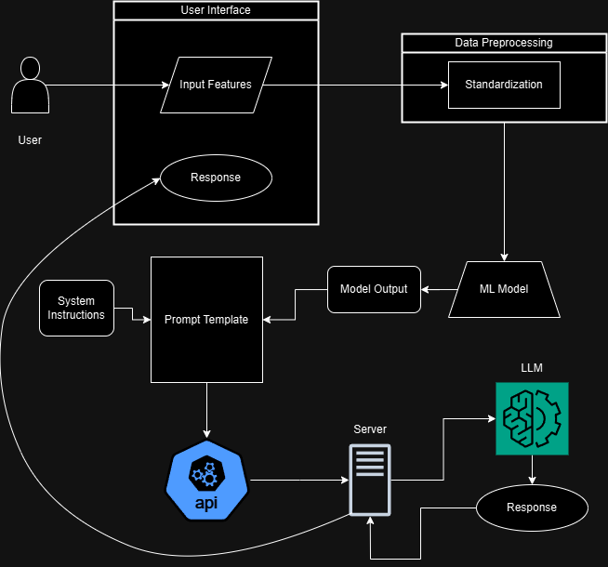

Fig 5.1 Architecture Diagram of Crop Recommendation System

**5.1.1 DATA COLLECTION**

The data collection process for the Crop Recommendation System involved gathering two primary datasets to train and validate the machine learning models. These datasets consist of tabular data containing soil properties, climatic conditions, and historical crop yields. Together, they provide a comprehensive foundation for accurately predicting the most suitable crops for specific environmental and soil conditions.

**Tabular Dataset**

The primary dataset for the machine learning model was sourced from Kaggle, a platform known for high-quality datasets across diverse domains. This dataset contains 3,000 rows and 8 columns, with each row representing an observation of soil and climatic conditions, and the columns comprising key features such as nitrogen (N), phosphorus (P), and potassium (K) content, temperature, humidity, soil pH, and rainfall. Additionally, a target column specifies the most suitable crop for the given conditions.

After thorough analysis, seven input features were identified as the most significant predictors of crop suitability, along with one target variable. These features represent critical environmental and soil factors that influence crop growth and yield. The dataset’s large size and diverse conditions ensure that the machine learning model can generalize effectively, providing robust and reliable predictions for various regions and climates.

**Preprocessing and Standardization**

All collected data underwent preprocessing to ensure consistency and quality. For the tabular dataset:

* Handling Missing Data: Rows with missing or invalid values were imputed or removed.
* Normalization: Continuous features such as temperature, humidity, and soil nutrients were normalized to a standard scale to improve model performance.
* Categorical Encoding: Target crop labels were converted into numerical values using one-hot encoding to facilitate model training.

**Significance of the Data**

The combination of a robust tabular dataset and the potential integration of image data positions the Crop Recommendation System to deliver precise and actionable crop recommendations. By leveraging high-quality, diverse datasets, the system addresses various factors influencing crop growth, ensuring that the recommendations are both comprehensive and reliable. This approach forms the basis for enhancing agricultural productivity and sustainability through data-driven decision-making.

**5.1.2 DATA PREPROCESSING**

Data preprocessing is a critical step in preparing the datasets for the Crop Recommendation System, ensuring that the input data is clean, consistent, and optimized for accurate predictions. Both the tabular dataset and any potential image datasets undergo a series of preprocessing steps to address issues like missing values, outliers, inconsistent formats, and scale discrepancies.

The tabular dataset, sourced from Kaggle, contains soil and climatic features critical for crop recommendation. To ensure its quality and compatibility with machine learning models, the following preprocessing steps were performed:

Handling Missing Values: Rows with missing or invalid data entries were carefully analyzed. Missing values were imputed using statistical methods such as mean or median imputation to retain as much data as possible while maintaining dataset integrity.

Outlier Detection and Treatment: Outliers were identified using statistical methods such as Z-scores or the interquartile range (IQR). Outliers that deviated significantly from the typical range were either capped to fall within acceptable thresholds or removed to prevent skewing the model’s training process.

Normalization and Standardization: Continuous features, such as nitrogen, phosphorus, potassium content, temperature, and rainfall, were normalized to bring them onto a similar scale. This step ensures that no single feature dominates the model’s learning process, improving convergence during training.

Feature Selection: From the original dataset, ten input features were selected based on their relevance to crop prediction. These features included critical soil and climatic parameters, while the target column was retained as the output variable.

Encoding Categorical Variables: If present, categorical features such as crop labels were encoded using one-hot encoding to convert them into a numerical foat suitable for model training.

**5.1.3 FEATURE EXTRACTION**

Feature extraction is a critical step in isolating and selecting the most significant variables from the dataset to train the machine learning model for the Crop Recommendation System. From the original dataset containing 12 columns, a refined set of 7 input features was selected based on their relevance to crop suitability and their ability to influence the model’s predictive performance. These features were identified as critical factors in determining crop growth, soil health, and environmental compatibility.

The following features were selected for model training:

Nitrogen (N), Phosphorus (P), and Potassium (K) Content: These macronutrients are essential for plant growth and are among the most influential factors in determining soil fertility. The levels of nitrogen, phosphorus, and potassium in the soil directly affect crop yield and health, making them indispensable inputs for the model.

Soil pH: Soil pH is a critical measure of soil acidity or alkalinity, which influences nutrient availability and microbial activity. Different crops thrive in specific pH ranges, making this a key feature for predicting crop suitability.

Temperature (°C): Temperature is a vital climatic factor that impacts germination, growth, and yield. By including this feature, the model accounts for the thermal conditions of the region, ensuring that the recommended crops are well-suited to the prevailing temperatures.

Humidity (%): Humidity affects transpiration rates, water availability, and pest activity. This feature helps the model identify crops that can thrive under the given atmospheric moisture levels.

Rainfall (mm): Rainfall data provides insights into water availability, which is essential for irrigation and overall crop development. By analyzing precipitation patterns, the model predicts crops that are best suited to the moisture levels in a specific region.

Crop (Target Variable): This is the target output variable that specifies the most suitable crop for the given soil and climatic conditions. The model learns to map the input features to the target variable, enabling accurate and reliable predictions.

Importance of Feature Selection

The selection of these features was driven by domain knowledge and statistical analysis, ensuring that only the most relevant variables were included in the model. Each feature was evaluated for its influence on crop growth and its ability to capture critical environmental and soil dynamics. The refined feature set not only improves the model’s efficiency but also ensures robust and interpretable predictions.

By focusing on these key features, the system is trained to understand the complex relationships between soil properties, climatic conditions, and crop requirements. This comprehensive approach enhances the model’s ability to provide precise and actionable crop recommendations, empowering farmers to make data-driven decisions that optimize yield and sustainability.

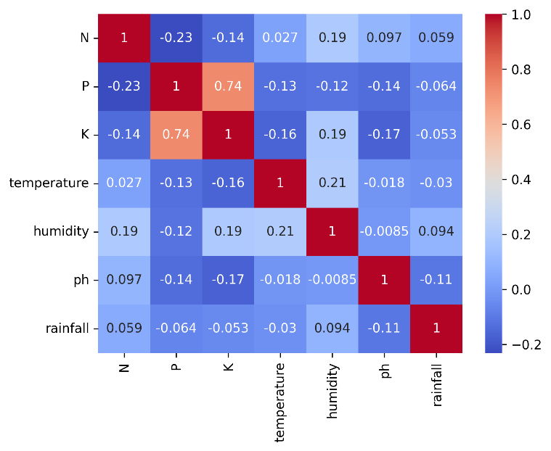

Fig 5.1.3.1 Correlation Analysis

**5.1.4 MODEL TRAINING**

The Crop Recommendation System was designed to leverage machine learning and deep learning models for accurate and reliable predictions. The training process involved a systematic approach, including data preprocessing, model selection, hyperparameter tuning, and performance evaluation. Various algorithms were evaluated to identify the most effective model, ensuring robust performance across diverse agricultural conditions.

**ML Model Development**

The development process involved training six models: Logistic Regression, Decision Tree, Random Forest, Support Vector Classifier (SVC), XGBoost, and a Deep Learning model (ANN). These models were chosen for their ability to handle tabular data and their diversity in learning strategies.

* Logistic Regression: A simple yet interpretable statistical model for binary and multiclass classification. It provides probability estimates for class membership, making it a good baseline model.
* Decision Tree: A non-parametric algorithm that partitions the dataset based on feature splits, providing interpretable results. It is effective for datasets with non-linear relationships.
* Random Forest: An ensemble learning method that combines multiple decision trees to improve accuracy and generalization. Known for its robustness and ability to handle diverse features.
* Support Vector Classifier (SVC): A kernel-based algorithm that identifies the hyperplane separating classes. Its flexibility in handling linear and non-linear relationships makes it a strong candidate.
* XGBoost: An optimized gradient-boosting algorithm that iteratively refines predictions. It is particularly effective for structured data and offers superior speed and efficiency.
* Deep Learning (ANN): A neural network-based model with multiple layers that captures complex, hierarchical relationships in data, suitable for handling subtle patterns and large datasets.

**Data Preparation and Splitting**

The dataset underwent preprocessing to ensure high-quality inputs:

* Features were standardized using StandardScaler, ensuring a mean of zero and a standard deviation of one, which is crucial for models sensitive to scaling.
* The dataset was split into training and testing sets with an 80:20 ratio, preserving a portion of data for evaluating generalization capabilities.

**Model Evaluation Results**

Each model was evaluated using metrics such as accuracy, precision, recall, and F1-score. These metrics provided a comprehensive assessment of the model's effectiveness in predicting suitable crops.

**Summary of Metrics:**

* Accuracy: All models demonstrated strong performance, with Random Forest achieving the highest accuracy (99.32%).
* Precision: Precision values were consistent across models, reflecting accurate positive predictions.
* Recall: High recall scores, especially for Random Forest and XGBoost, indicate the models’ ability to capture true positives effectively.
* F1-Score: Balanced scores across models highlight their robustness and suitability for deployment.
* Final Model Selection: Random Forest
* The Random Forest model emerged as the top performer, achieving:
  + Accuracy: 99.32%
  + Precision: 99.35%
  + Recall: 99.32%
  + F1-Score: 99.32%

Its ensemble structure, robustness to overfitting, and capability to handle diverse features make it ideal for the Crop Recommendation System. Random Forest’s ability to generalize well across varying conditions ensures reliable predictions, making it suitable for practical agricultural applications.

**Conclusion**

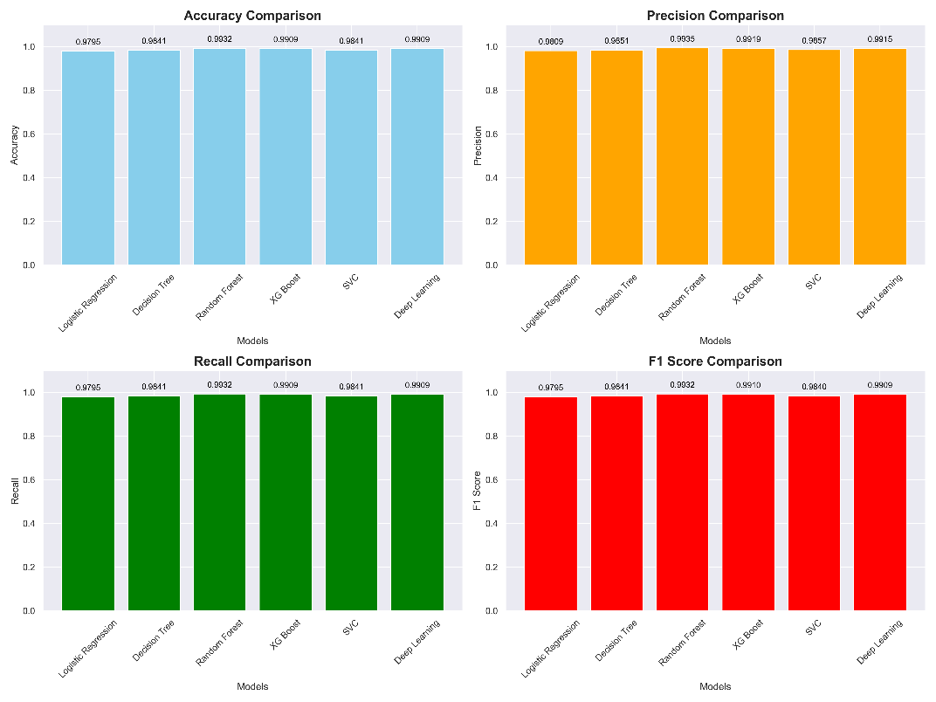The systematic evaluation and fine-tuning of multiple models revealed Random Forest as the most effective algorithm for crop recommendation. Its high accuracy and balanced metrics make it a dependable choice for deployment, providing farmers with actionable insights to optimize crop selection and enhance agricultural productivity.

Fig 5.1.4.1 ML Model Performance Metrics

**5.1.5 EVALUATION AND PERFORMANCE METRICS**

The evaluation and performance metrics for the Crop Recommendation System showcase the robustness and reliability of the machine learning and deep learning models in providing accurate crop predictions. The models were assessed on metrics such as accuracy, precision, recall, and F1-score to ensure a comprehensive evaluation of their performance.

**Evaluation of Machine Learning Models**

The machine learning models, trained on structured soil and climatic data, demonstrated strong performance across various metrics. Among the models tested, **Random Forest** emerged as the best-performing model, achieving the highest accuracy, precision, recall, and F1-score. The results for each model are summarized below:

* **Logistic Regression**: Achieved an accuracy of 97.95%, offering a simple yet interpretable baseline model for comparison.
* **Decision Tree**: Showed improved performance with an accuracy of 98.41%, leveraging its ability to handle non-linear relationships in the data.
* **Random Forest**: Outperformed all other models with an accuracy of 99.32%, showcasing its robustness and ability to handle diverse features and interactions effectively.
* **Support Vector Classifier (SVC)**: Achieved a competitive accuracy of 99.09%, with high precision and recall, benefiting from its ability to model complex feature spaces.
* **XGBoost**: Delivered an accuracy of 99.10%, with strong performance in recall, highlighting its capability to correctly identify suitable crops.
* **Deep Learning (ANN)**: Reached an accuracy of 99.09%, demonstrating its potential for capturing complex, hierarchical relationships in the data.

**Performance Metrics Summary**

The models were evaluated using the following metrics:

* **Accuracy**: Measures the percentage of correct predictions among all predictions.
* **Precision**: Indicates the proportion of true positive predictions out of all positive predictions.
* **Recall**: Reflects the proportion of true positive predictions out of all actual positives.
* **F1-Score**: The harmonic mean of precision and recall, providing a balanced assessment of the model’s performance.

**5.2 INPUT AND OUTPUT DESIGN**

**5.3 DATABASE**

Currently, the **Crop Recommendation System** operates without an integrated database. However, in future iterations, a database module may be introduced to manage and store user inputs, model predictions, and generated reports. The inclusion of a database would enhance the system’s functionality by enabling historical data tracking, personalized recommendations, and longitudinal analysis.

**Future Database Features:**

* **User Data**: To store user information, including session history and regional preferences, for a more tailored user experience.
* **Input Data Storage**: To retain soil properties and climatic conditions submitted by users, allowing for analysis over time.
* **Model Predictions**: To archive recommended crops and associated confidence levels for longitudinal studies and user feedback loops.
* **Feedback and Reports**: To capture user feedback and store generated recommendation reports for easy retrieval and analysis.

**Security Considerations:**

If implemented, the database would prioritize:

* **Data Encryption** for protecting sensitive information.
* **Role-Based Access Control** to limit database interaction based on user roles.
* **Regular Backups** to ensure data integrity and prevent loss.

Currently, all operations rely on real-time data processing without persistent storage, which simplifies the system but limits its capacity for historical analysis and future personalization.

**5.4 SYSTEM MODULES**

The **Crop Recommendation System** is composed of several interconnected modules, each serving a distinct purpose in the overall workflow. Together, these modules ensure efficient data handling, accurate predictions, and user-friendly interaction. Below are the key system modules.

**Data Collection Module**

Manages the acquisition of environmental and soil data required for crop recommendations. Users provide inputs such as nitrogen, phosphorus, and potassium levels, along with temperature, humidity, pH, and rainfall. The module ensures these inputs are structured and ready for analysis

**Preprocessing Module**

Handles data cleaning and preparation to improve model performance. Key preprocessing steps include:

* Handling missing values through imputation.
* Normalizing soil and environmental parameters to standardize input scales.
* Encoding categorical variables where necessary. This module ensures that the data is clean, consistent, and compatible with the machine learning models.

**Model Training Module**

Responsible for training the machine learning models, including Logistic Regression, Decision Tree, Random Forest, SVC, XGBoost, and Deep Learning (ANN). The models learn patterns from preprocessed data and are fine-tuned using techniques such as RandomizedSearchCV and Keras Tuner. This module ensures that models achieve high accuracy and generalization capabilities.

**Prediction and Analysis Module**

Deployed models predict the most suitable crops based on user inputs. This module integrates outputs from the machine learning models and generates comprehensive crop recommendations, including confidence scores and insights into the key factors influencing the recommendations.

**Report Generation Module**

Creates detailed, user-friendly reports that include:

* The recommended crop for the given conditions.
* An explanation of why the crop was selected.
* Suggestions for improving soil health and optimizing crop yield.  
  These reports enhance the system’s interpretability and usability, empowering users with actionable insights.

**User Interface Module**

Currently implemented using **Gradio**, this module provides an intuitive frontend for data input and viewing of recommendations. Users can interact with the system through a simple, web-based interface. Future upgrades may involve transitioning to **React.js** for a more dynamic and feature-rich user experience.

While the system currently processes data in real-time without persistent storage, its modular design ensures that a database can be seamlessly integrated in future iterations to further enhance functionality and scalability.

**CHAPTER 6**

**CONCLUSION AND FUTURE WORKS**

**6.1 CONCLUSION**

The development of the **Crop Recommendation System** leverages state-of-the-art machine learning and deep learning models to provide accurate and actionable crop recommendations based on soil and environmental data. By combining traditional algorithms like Random Forest, XGBoost, and SVC with advanced deep learning techniques, the system delivers a robust, data-driven solution to address the challenges of modern agriculture. The Random Forest model emerged as the best-performing algorithm, achieving the highest accuracy and balanced metrics, validating its effectiveness in handling diverse features and interactions.

The system architecture incorporates well-defined modules for data collection, preprocessing, model training, prediction, and report generation. By implementing techniques like hyperparameter tuning, feature selection, and data standardization, the models achieved strong performance metrics, ensuring reliability and scalability. The user-friendly interface allows farmers and agricultural professionals to access crop recommendations effortlessly, empowering them to optimize productivity and sustainability. This project represents a significant advancement in applying artificial intelligence to agriculture, offering a scalable and adaptable solution to enhance crop management practices.

**6.2 FUTURE WORKS**

While the current system demonstrates strong performance and usability, there are several areas for future enhancement and expansion:

* **Integration of Real-Time Data**: Incorporating real-time data from weather APIs, soil sensors, and satellite imagery could make recommendations more dynamic and context-aware, allowing the system to respond to changing environmental conditions.
* **Mobile Application Development**: Extending the system to mobile platforms with an intuitive interface would improve accessibility, particularly for smallholder farmers in remote areas. IoT-enabled devices could streamline data collection and recommendation delivery.
* **Advanced Generative AI Integration**: Employing generative AI to create detailed and visually intuitive reports can enhance user understanding and decision-making, particularly for non-technical users.
* **Scaling to Regional and Global Levels**: Expanding the system to accommodate more crops and regional datasets would improve its applicability across diverse agricultural zones, ensuring its relevance in different climatic and soil conditions.
* **Multi-Modal Analysis**: Integrating image-based analysis, such as satellite imagery and soil texture detection, could complement structured data inputs, providing a more comprehensive approach to crop recommendation.
* **Database Integration**: A future implementation of a database module would allow for data storage and longitudinal analysis, enabling historical tracking of recommendations and outcomes, and facilitating continuous improvement of the system.
* **Diagnosis of Pest and Disease Risks**: Expanding the system to include predictive models for pest infestations and crop diseases would further support farmers in managing their fields effectively.